Group Contract

The success of this project relies on the group cooperating as a team and completing each task to their upmost ability. To meet this goal, we are creating a couple of rules that will need to be followed by each member. The rules are as follows.

> Each group member shows up to the Monday 3pm meetings on time.

> Each group member completes their tasks to their upmost ability and communicates any issues to the rest of the group

> Each group member has to complete at least 1 task per week or have made significant progress on a task

> Each member will take a turn to be scrum master and remain in contact with the scrum master or the rest of the group if they are the scrum master

> Each member will contribute in order to ensure the group as a whole is punctual with deadlines.

Other rules you wish to add, add below:

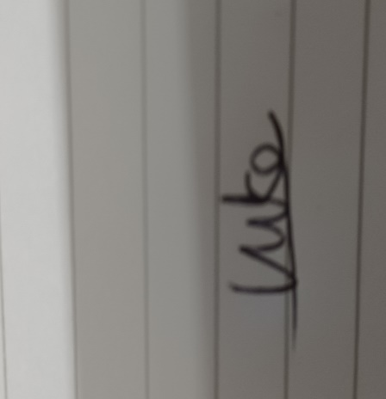

Print your name and sign below: Date 24/01/2022

Print Name: Luke Yaxley Signature:

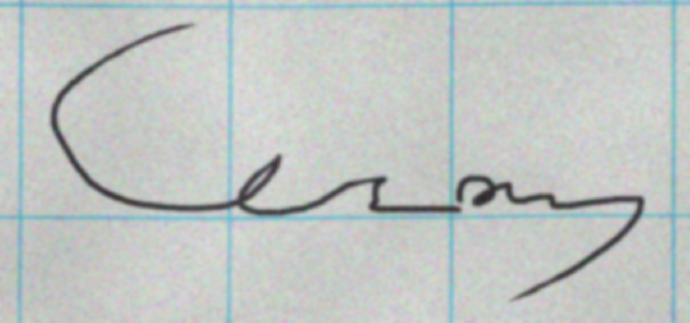

Print Name: Cezary Szymanski Signature:

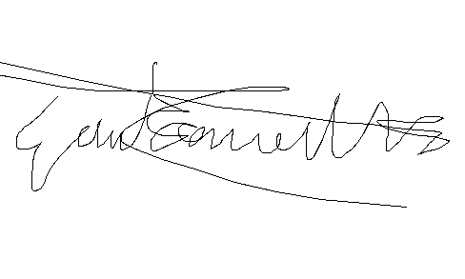

Print Name: George Wilson-Wallis Signature:

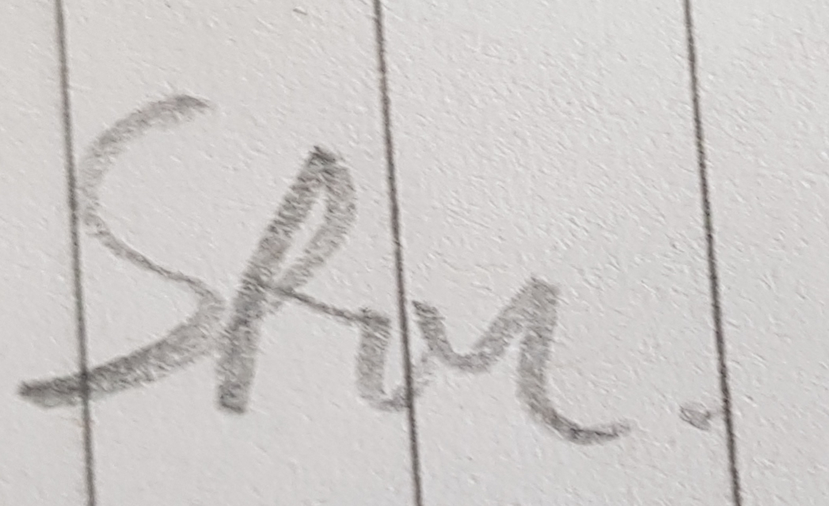

Print Name: Jakub Stec Signature:

Print Name: Harsh Palresha Signature:

Print Name: Signature: